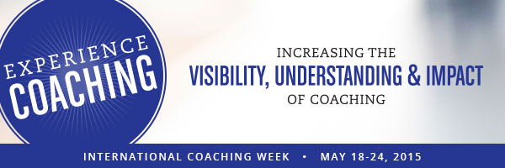

You are invited to the

3rd International Coaching Week, Coach Café, May 18-24, 2015

Where: On-site at your business in Southeastern Michigan. Offer limited to the first four requests.

What: Coach Cafe Ann Arbor is offering selected leaders pro bono speed coaching panels from some of the top coaches in Michigan. This is in honor of International Coaching Week to Take Charge of Your Future. We are scheduling for May 18-24 and other dates in May, early June if needed.

Why? We are continuing to build partnerships in a win-win opportunity. All we request is that you provide in-house publicity (see a sample from last year here), and a place for us to meet with your staff.

RSVP: Contact one of the coaches below as soon as possible to schedule your speed coaching session. A limited number of 1 hour speed coaching sessions are available, so reserve your time as soon as possible.

Participating coaches:

Amy Lavi , Life Coach, Executive Coach
Amy on LinkedIn amyjlavi@gmail.com
Certified, passionate coach for professionals

Deb Nystrom, Executive and Leadership Teams Coach

REVELN.com Deb’s LinkedIn Profile Web: DebNystrom@REVELN.com

Change & Performance | Leadership| Org. Development | Social Media

Debbie Merion, MFA, MSW, Writing and Communications Coach
EssayCoaching.com debbiemerion.com Deb on LinkedIn Debbie@essaycoaching.com
Creating powerful and compelling content for marketing, books, bios and profiles

Geraldine Markel, PhD., Leadership and Productivity Coach

www.gerimarkel.com Geri on Linkedin geri@ManagingYourMind.com

Productivity and Life Satisfaction

Leon Wyszewianski, PhD., Career Counselor, Life Coach, Executive Coach
LeonwCounseling.com leonw23@gmail.com
Managing One's Career; Balancing the Demands of Work and Life.

To schedule your 2015 session, register with a participating coach: Coach Cafe Ann Arbor website here.
http://coachcafeannarbor.weebly.com/intl-coaching-week.html

